TASK 3
MLT
T.Bindu(VTU30569)

import numpy as np
import matplotlib.pyplot as plt

from sklearn.datasets import make_classification
from sklearn.decomposition import PCA
from sklearn.discriminant_analysis import LinearDiscriminantAnalysis as LDA
from sklearn.model_selection import train_test_split
from sklearn.ensemble import RandomForestClassifier
from sklearn.metrics import accuracy_score

X, y = make_classification(
n_samples=500,
n_features=20,
n_informative=10,
n_redundant=5,
n_classes=3,
n_clusters_per_class=1,
random_state=42
)

X_train, X_test, y_train, y_test = train_test_split(
X,
y,
test_size=0.3,
random_state=42,
stratify=y
)

pca = PCA(n_components=2)

X_train_pca = pca.fit_transform(X_train)
X_test_pca = pca.transform(X_test)

lda = LDA(n_components=2)

X_train_lda = lda.fit_transform(X_train, y_train)
X_test_lda = lda.transform(X_test)

plt.figure(figsize=(12, 6))

plt.subplot(1, 2, 1)

for class_value in np.unique(y_train):
plt.scatter(
X_train_pca[y_train == class_value, 0],
X_train_pca[y_train == class_value, 1],
label=f'Class {class_value}'
)

plt.title("PCA Visualization")
plt.xlabel("Principal Component 1")
plt.ylabel("Principal Component 2")
plt.legend()
plt.grid(True)

plt.subplot(1, 2, 2)

for class_value in np.unique(y_train):
plt.scatter(
X_train_lda[y_train == class_value, 0],
X_train_lda[y_train == class_value, 1],
label=f'Class {class_value}'
)

plt.title("LDA Visualization")
plt.xlabel("Linear Discriminant 1")
plt.ylabel("Linear Discriminant 2")
plt.legend()
plt.grid(True)

plt.tight_layout()
plt.show()

clf_original = RandomForestClassifier(
random_state=42
)

clf_original.fit(X_train, y_train)

y_pred_original = clf_original.predict(X_test)

original_accuracy = accuracy_score(
y_test,
y_pred_original
)

clf_pca = RandomForestClassifier(
random_state=42
)

clf_pca.fit(X_train_pca, y_train)

y_pred_pca = clf_pca.predict(X_test_pca)

pca_accuracy = accuracy_score(
y_test,
y_pred_pca
)

clf_lda = RandomForestClassifier(
random_state=42
)

clf_lda.fit(X_train_lda, y_train)

y_pred_lda = clf_lda.predict(X_test_lda)

lda_accuracy = accuracy_score(
y_test,
y_pred_lda
)

print("Classification Accuracy Comparison")
print("-----------------------------------")
print(f"Accuracy on Original Data: {original_accuracy:.2f}")
print(f"Accuracy on PCA-Reduced Data: {pca_accuracy:.2f}")
print(f"Accuracy on LDA-Reduced Data: {lda_accuracy:.2f}")

OUTPUT:
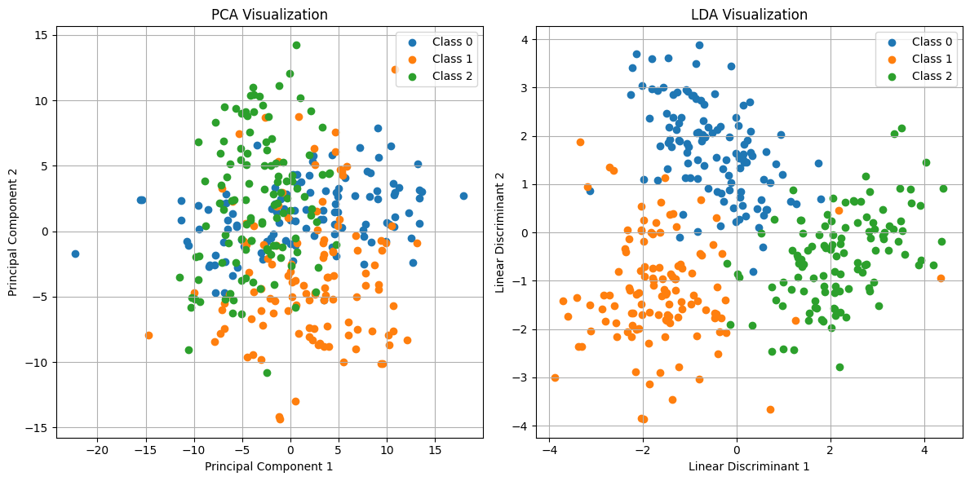
Classification Accuracy Comparison
-----------------------------------
Accuracy on Original Data: 0.94
Accuracy on PCA-Reduced Data: 0.64
Accuracy on LDA-Reduced Data: 0.95

